* **Lab :- 01**



* **Topic :-** create a table Client_Master with following attributes :-



**[ Client No, Name, Address1, Address2, City, Pin code,**



**State, Bal Due]**

Insert a record in this table and retrieve the same.

* **Inserting two different records in the table :-**



In our Case it is CL001 & CL002

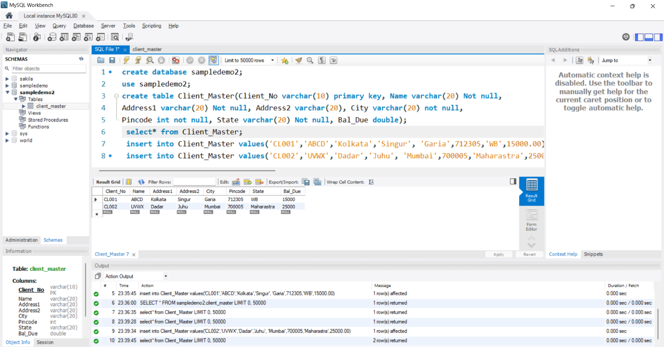

* **Retrieving (Deleting) one record from the table :-**



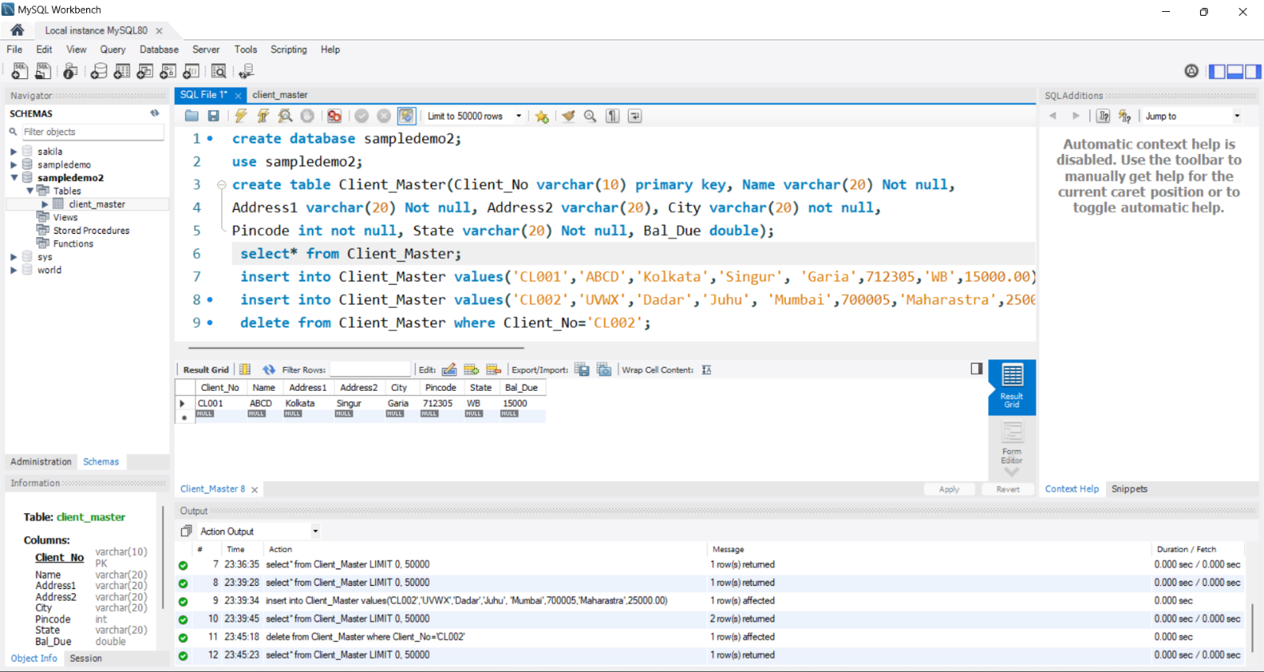

Here record [ Client No- CL002 ] deleted or retrieved.